PROJECT 4 AWS ADVANCE -LU
GIT PROJECT:
Task1: create a repository in github
● Git init
Git init is a command that is used to initialize a repository
● Both config commands
Commands to use are; git config –global user.email <email address>
And git config –global user.name <github name>
Screenshot for git init
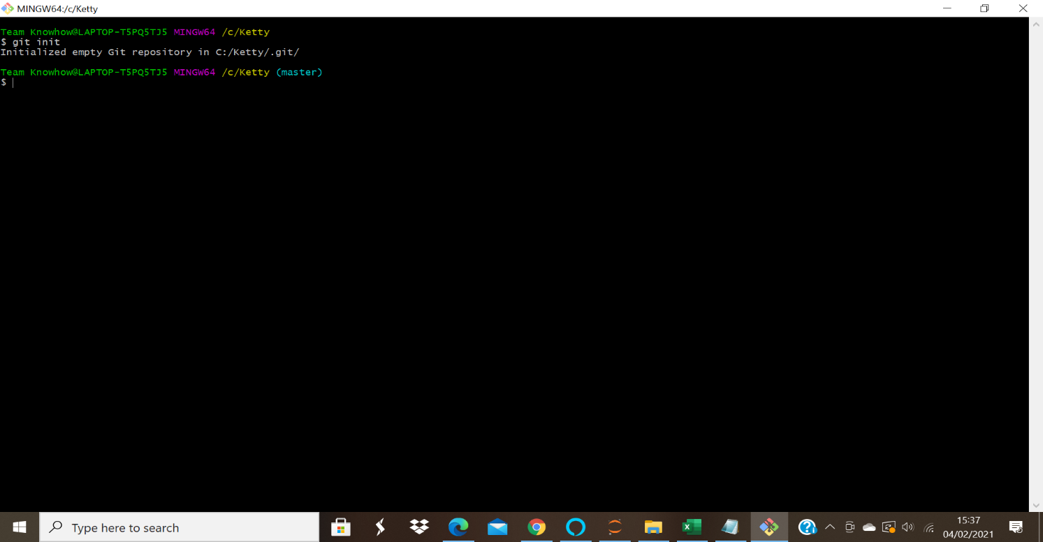

Screenshot for git config commands: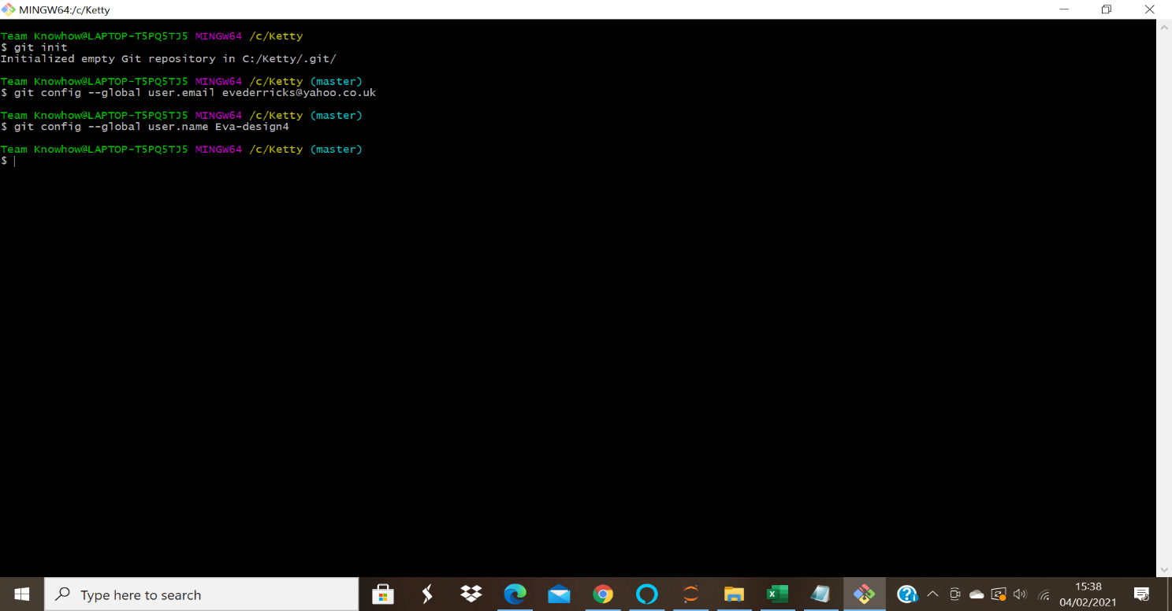

Task2: open git bash and clone contents from remote repository
● clone
To clone use git clone < url for the repository>
● show the folder in local repository
Sreenshot for the folder in the local repository:
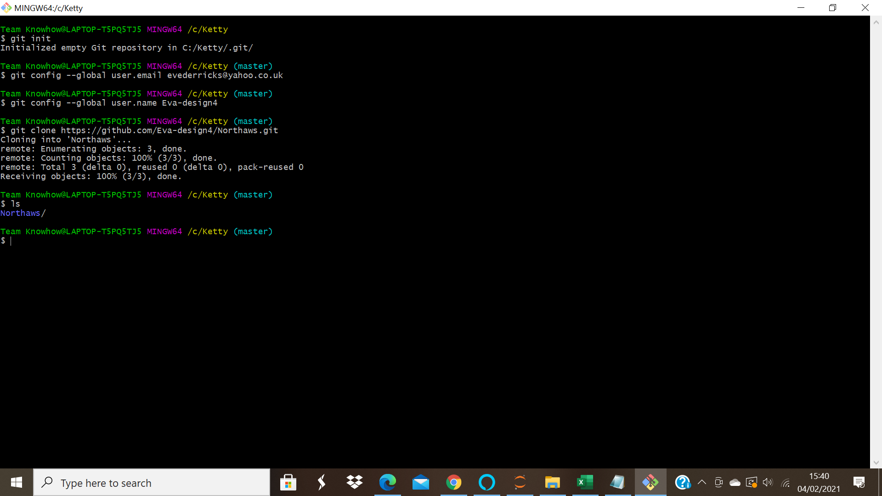
Task3: create a file in the local space and push it to the remote repository
To create a file use command touch <filename>
● add
Command to use is git add <file name>
Screenshot for the add command;
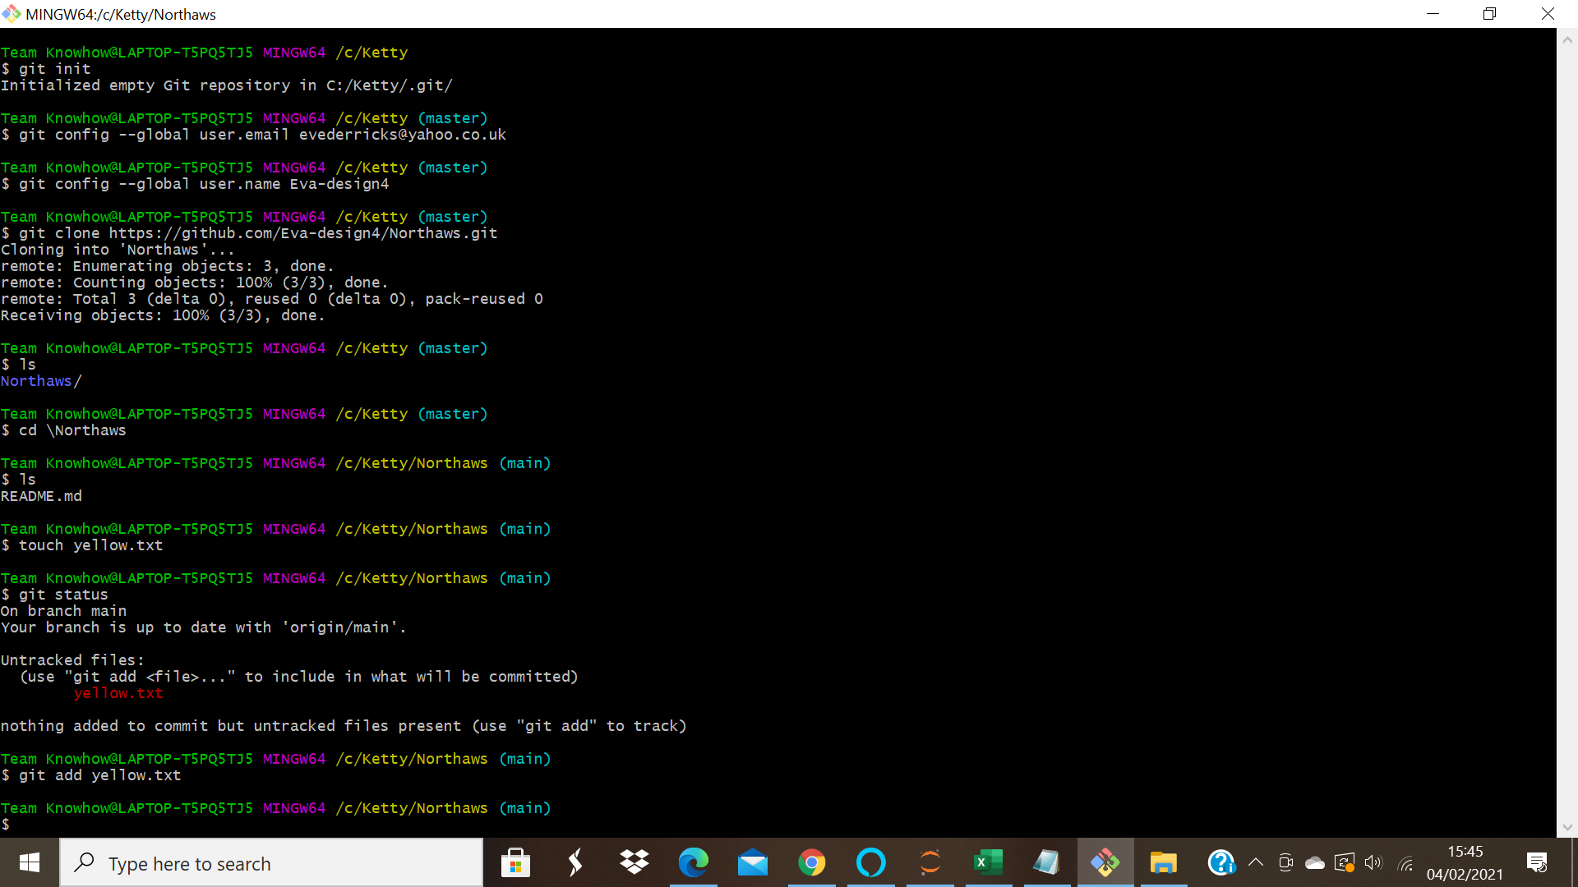
● commit
Use git commit -m “first” <file name>
ScreenShot for git commit:
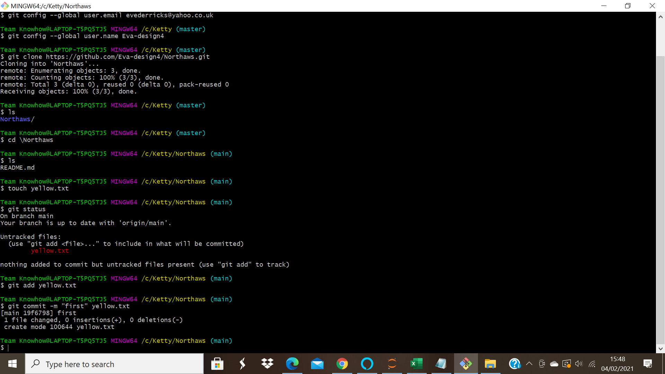
● push successful
Command to use is git push -u origin main
Screenshot for successful push:
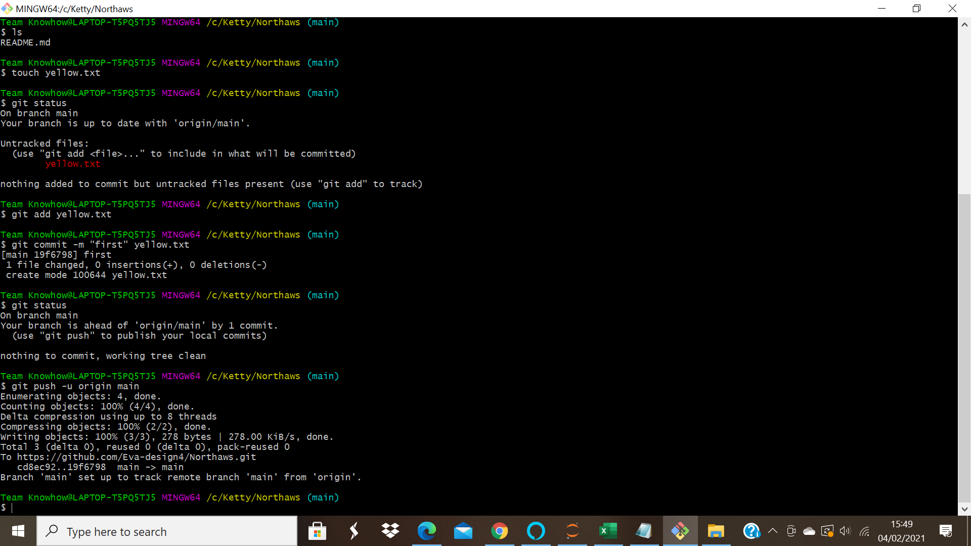
● show the file in remote repository
Screenshot for the file in remote repository:
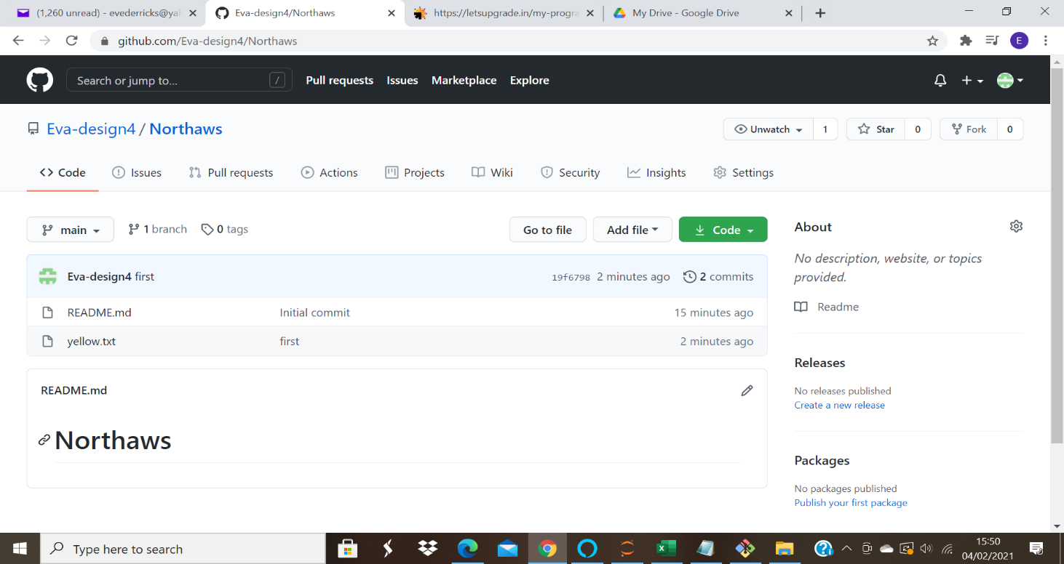
Task4: Branching and merging
Execute all commands and add screenshots.

Git branching:
● git branch
Git branch list the available branches
Screenshot for git branch:
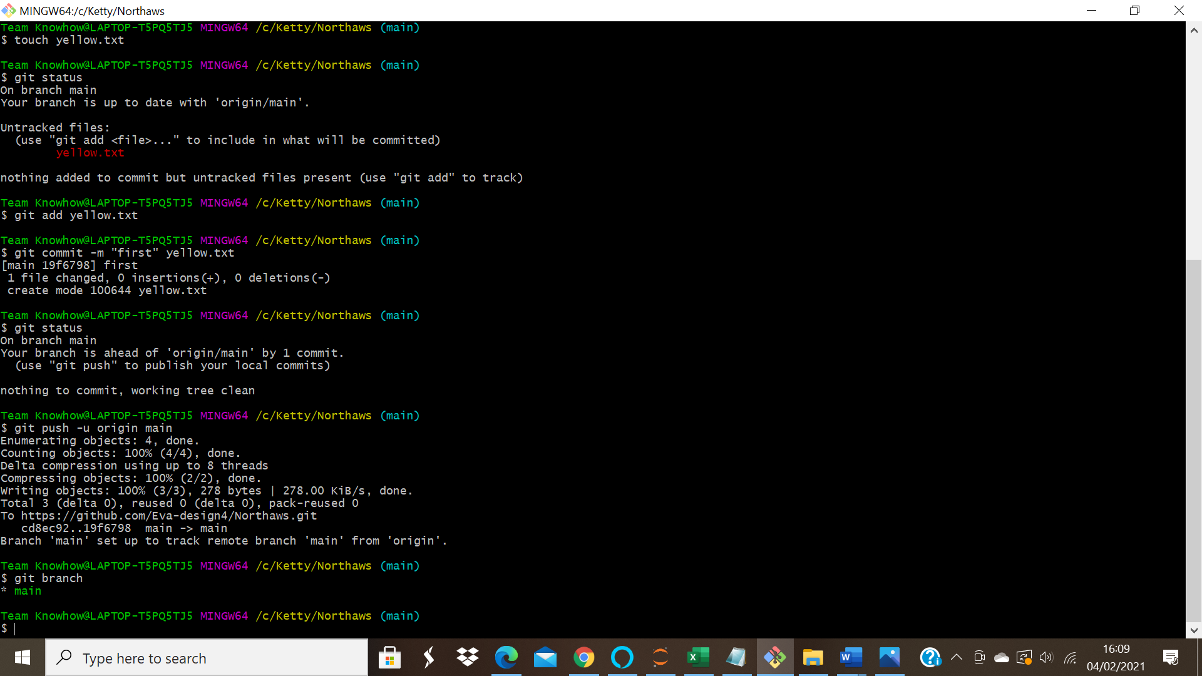
● git branch branch name
This command creates a new branch
● git checkout branchname
Git checkout is for moving to a particular branch
Screenshot for the newly created branch; and checkout command
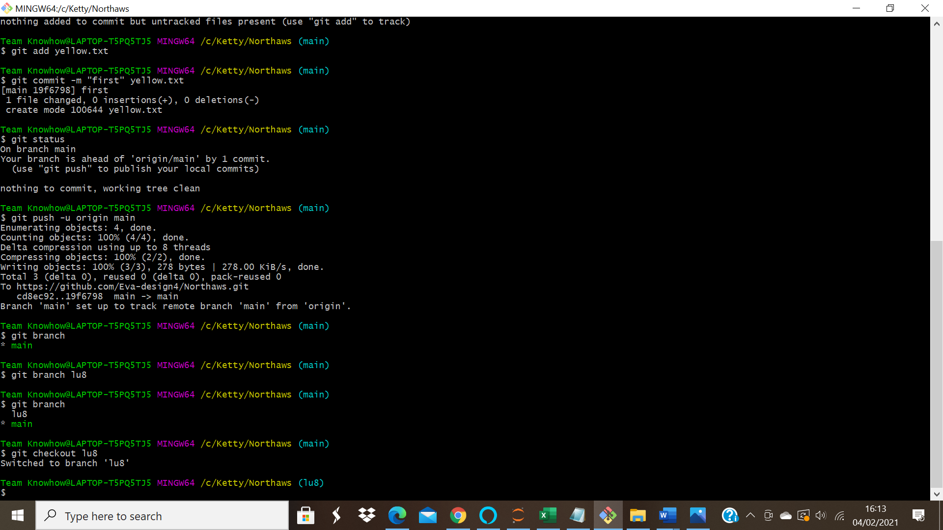
● git merge branchname
This command is used to merge contents of branches into main branch
Screenshot for merge command;
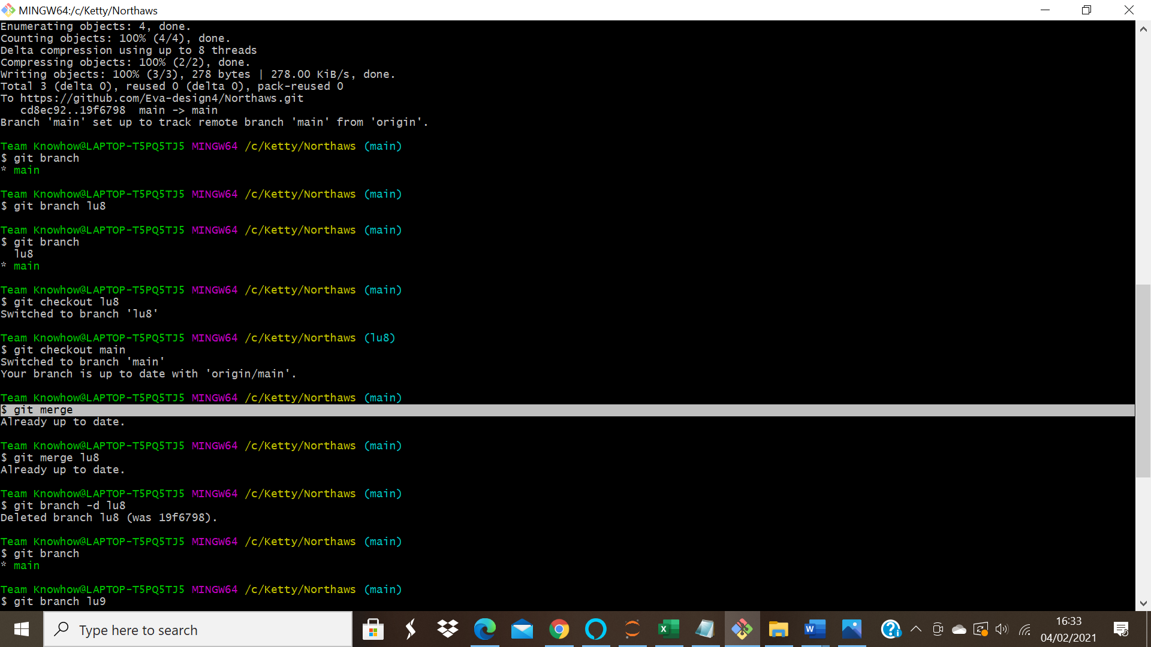

● git branch -d branchname
This command is for deleting the branch.
Screenshot of the executed command:
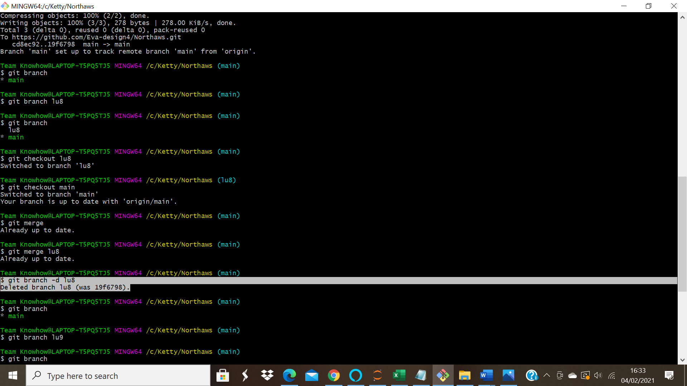

● git branch -D branchname
This is to force delete a branch
Screenshot;
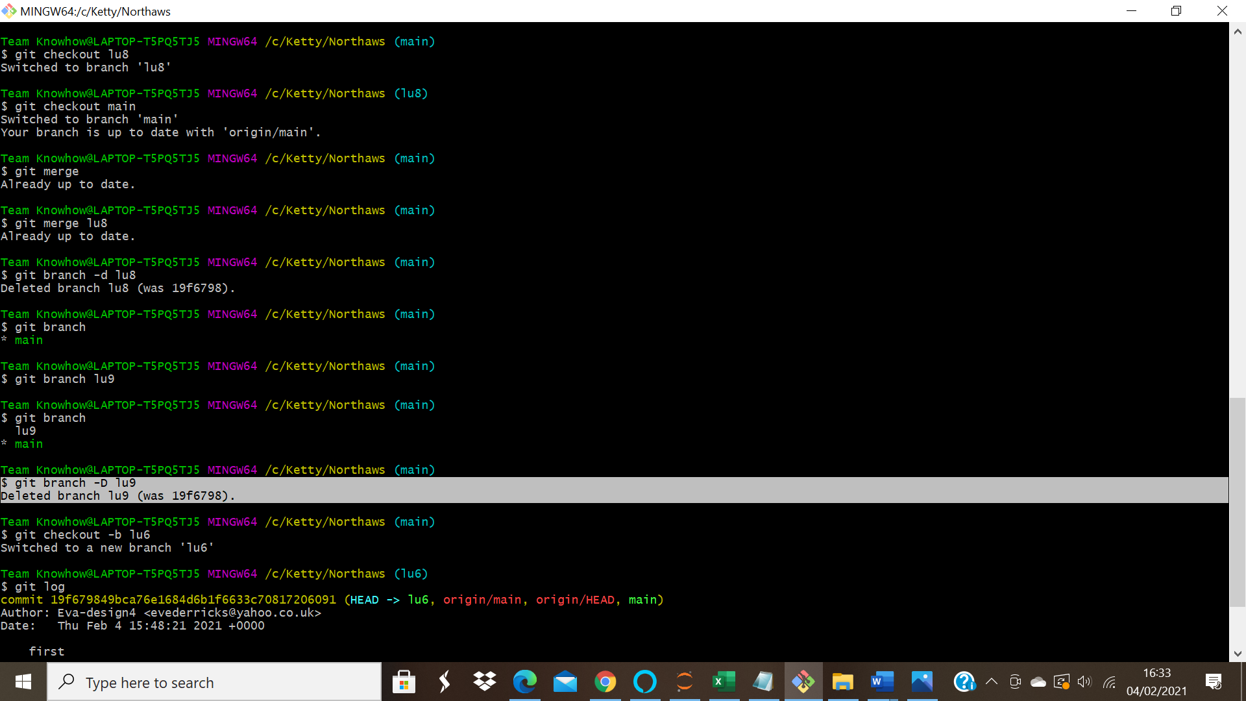
● git checkout -b branchname
This creates a new branch and moves directly into it.
Screenshot for the newly created and switched into branch;
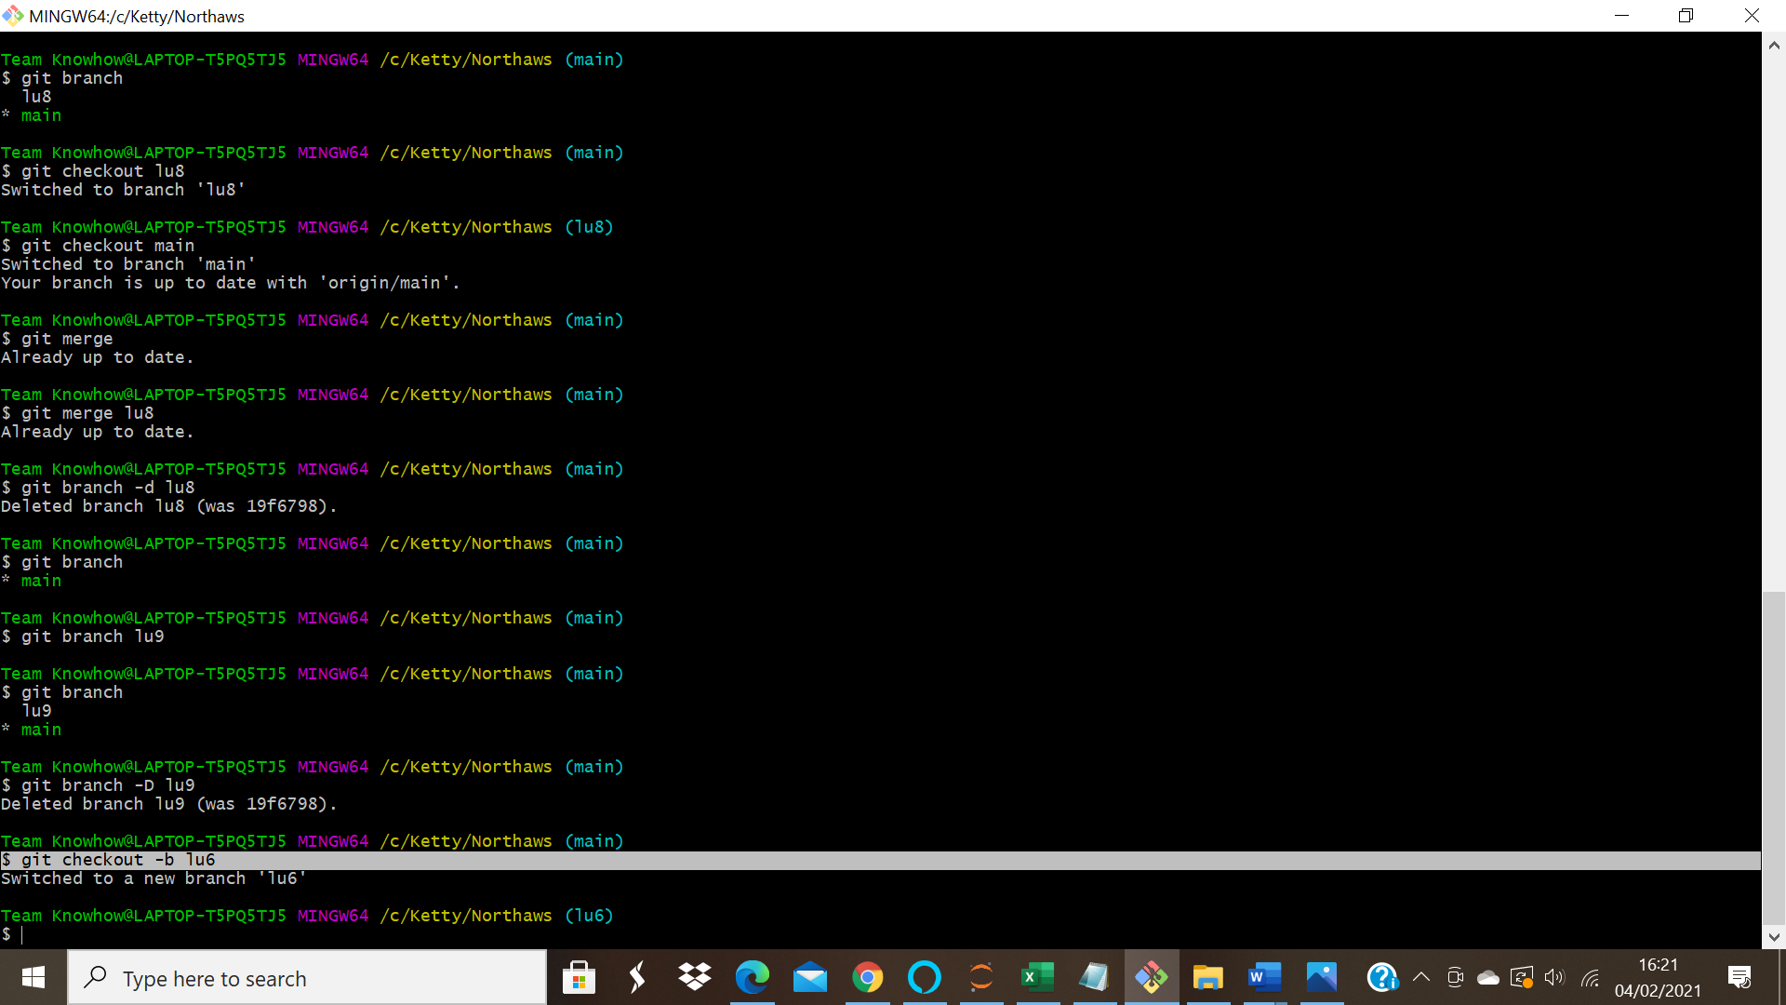

● git log
This gives the contents of the changes you have made.
